What is Clustering?

Cluster analysis is a technique used in data mining and machine learning to group similar objects into clusters. K-means clustering is a widely used method for cluster analysis where the aim is to partition a set of objects into K clusters in such a way that the sum of the squared distances between the objects and their assigned cluster mean is minimized.

Hierarchical clustering and k-means clustering are two popular techniques in the field of unsupervised learning used for clustering data points into distinct groups. While k-means clustering divides data into a predefined number of clusters, hierarchical clustering creates a hierarchical tree-like structure to represent the relationships between the clusters.

Example

Let’s try understanding this with a simple example. A bank wants to give credit card offers to its customers. Currently, they look at the details of each customer and, based on this information, decide which offer should be given to which customer.

Now, the bank can potentially have millions of customers. Does it make sense to look at the details of each customer separately and then make a decision? Certainly not! It is a manual process and will take a huge amount of time.

So what can the bank do? One option is to segment its customers into different groups. For instance, the bank can group the customers based on their income:

[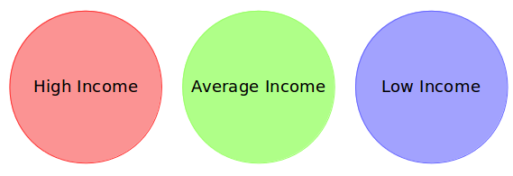](https://cdn.analyticsvidhya.com/wp-content/uploads/2019/08/Screenshot-from-2019-08-07-15-19-27.png)

Can you see where I’m going with this? The bank can now make three different strategies or offers, one for each group. Here, instead of creating different strategies for individual customers, they only have to make 3 strategies. This will reduce the effort as well as the time.

Can you guess which type of learning problem clustering is? Is it a supervised or unsupervised learning problem?

Think about it for a moment and use the example we just saw. Got it? Clustering is an unsupervised learning problem!

How is Clustering an Unsupervised Learning Problem?

Let’s say you are working on a project where you need to predict the sales of a big mart:

[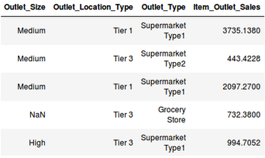](https://cdn.analyticsvidhya.com/wp-content/uploads/2019/08/Screenshot-from-2019-08-07-16-25-31.png)

Or, a project where your task is to predict whether a loan will be approved or not:

[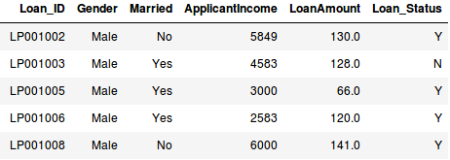](https://cdn.analyticsvidhya.com/wp-content/uploads/2019/08/Screenshot-from-2019-08-07-16-29-45.png)

We have a fixed target to predict in both of these situations. In the sales prediction problem, we have to predict the *Item_Outlet_Sales* based on *outlet_size, outlet_location_type*, etc., and in the loan approval problem, we have to predict the *Loan_Status* depending on the *Gender, marital status, the income of the customers, etc*.

**In clustering, we do not have a target to predict. We look at the data, try to club similar observations, and form different groups. Hence it is an unsupervised learning problem.**

We now know what clusters are and the concept of clustering. Next, let’s look at the properties of these clusters, which we must consider while forming the clusters.

## Properties of Clusters

How about another example? We’ll take the same bank as before, which wants to segment its customers. For simplicity purposes, let’s say the bank only wants to use the income and debt to make the segmentation. They collected the customer data and used a scatter plot to visualize it:

[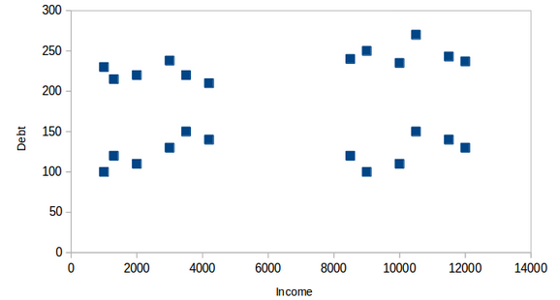](https://cdn.analyticsvidhya.com/wp-content/uploads/2019/08/Screenshot-from-2019-08-08-14-46-17.png)  
On the X-axis, we have the income of the customer, and the y-axis represents the amount of debt. Here, we can clearly visualize that these customers can be segmented into 4 different clusters, as shown below:

[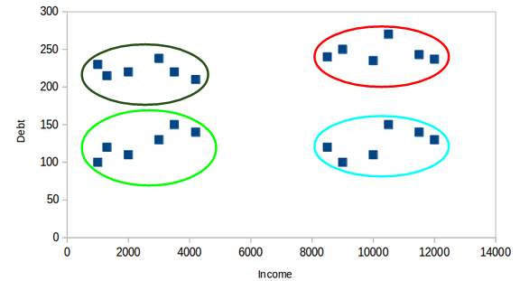](https://cdn.analyticsvidhya.com/wp-content/uploads/2019/08/Screenshot-from-2019-08-08-14-47-20.png)  
This is how clustering helps to create segments (clusters) from the data. The bank can further use these clusters to make strategies and offer discounts to its customers. So let’s look at the properties of these clusters.

First Property of K-Means Clustering Algorithm

**All the data points in a cluster should be similar to each other.** Let me illustrate it using the above example:[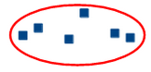](https://cdn.analyticsvidhya.com/wp-content/uploads/2019/08/Screenshot-from-2019-08-08-14-49-11.png)

If the customers in a particular cluster are not similar to each other, then their requirements might vary, right? If the bank gives them the same offer, they might not like it, and their interest in the bank might reduce. Not ideal.

Having similar data points within the same cluster helps the bank to use targeted marketing. You can think of similar examples from your everyday life and consider how clustering will (or already does) impact the business strategy.

Second Property of K-Means Clustering Algorithm

**The data points from different clusters should be as different as possible.** This will intuitively make sense if you’ve grasped the above property. Let’s again take the same example to understand this property:

[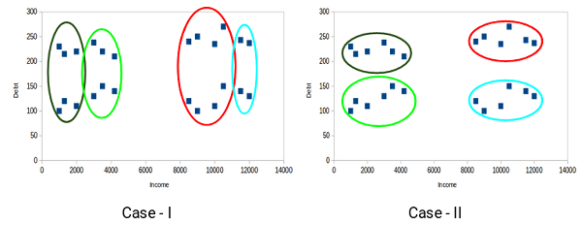](https://cdn.analyticsvidhya.com/wp-content/uploads/2019/08/Screenshot-from-2019-08-08-14-51-31.png)

Which of these cases do you think will give us the better clusters? If you look at case I:

[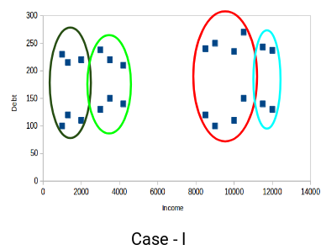](https://cdn.analyticsvidhya.com/wp-content/uploads/2019/08/Screenshot-from-2019-08-08-14-52-26.png)

Customers in the red and blue clusters are quite similar to each other. The top four points in the red cluster share similar properties to those of the blue cluster’s top two customers. They have high incomes and high debt values. Here, we have clustered them differently. Whereas, if you look at case II:

[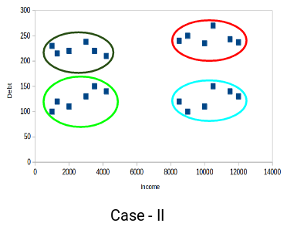](https://cdn.analyticsvidhya.com/wp-content/uploads/2019/08/Screenshot-from-2019-08-08-14-52-58.png)

Points in the red cluster completely differ from the customers in the blue cluster. All the customers in the red cluster have high income and high debt, while the customers in the blue cluster have high income and low debt value. Clearly, we have a better clustering of customers in this case.

Hence, data points from different clusters should be as different from each other as possible to have more meaningful clusters. The k-means algorithm uses an iterative approach to find the optimal cluster assignments by minimizing the sum of squared distances between data points and their assigned cluster centroid.

So far, we have understood what clustering is and the different properties of clusters. But why do we even need clustering? Let’s clear this doubt in the next section and look at some applications of clustering.

Applications of Clustering in Real-World Scenarios

Clustering is a widely used technique in the industry. It is being used in almost every domain, from banking and [recommendation engines](https://www.analyticsvidhya.com/blog/2018/06/comprehensive-guide-recommendation-engine-python/?utm_source=blog&utm_medium=comprehensive-guide-k-means-clustering) to document clustering and image segmentation.

Customer Segmentation

We covered this earlier – one of the most common applications of clustering is customer segmentation. And it isn’t just limited to banking. This strategy is across functions, including telecom, e-commerce, sports, advertising, sales, etc.

Document Clustering

This is another common application of clustering. Let’s say you have multiple documents and you need to cluster similar documents together. Clustering helps us group these documents such that similar documents are in the same clusters.

[](https://cdn.analyticsvidhya.com/wp-content/uploads/2019/08/Screenshot-from-2019-08-08-15-02-44.png)

Image Segmentation

We can also use clustering to perform image segmentation. Here, we try to club similar pixels in the image together. We can apply clustering to create clusters having similar pixels in the same group.

[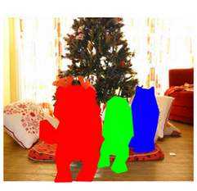](https://cdn.analyticsvidhya.com/wp-content/uploads/2019/08/Screenshot-from-2019-08-08-15-03-22.png)

You can refer to [this article](https://www.analyticsvidhya.com/blog/2019/04/introduction-image-segmentation-techniques-python/?utm_source=blog&utm_medium=comprehensive-guide-k-means-clustering) to see how we can use clustering for image segmentation tasks.

Recommendation Engines

Clustering can also be used in [recommendation engines](https://www.analyticsvidhya.com/blog/2018/06/comprehensive-guide-recommendation-engine-python/?utm_source=blog&utm_medium=comprehensive-guide-k-means-clustering). Let’s say you want to recommend songs to your friends. You can look at the songs liked by that person and then use clustering to find similar songs and finally recommend the most similar songs.

[](https://cdn.analyticsvidhya.com/wp-content/uploads/2019/08/Screenshot-from-2019-08-08-15-05-03.png)

There are many more applications that I’m sure you have already thought of. You can share these applications in the comments section below. Next, let’s look at how we can evaluate our clusters.

Understanding the Different Evaluation Metrics for Clustering

The primary aim of clustering is not just to make clusters but to make good and meaningful ones. We saw this in the below example:

[](https://cdn.analyticsvidhya.com/wp-content/uploads/2019/08/Screenshot-from-2019-08-08-14-51-31.png)

Here, we used only two features, and hence it was easy for us to visualize and decide which of these clusters was better.

Unfortunately, that’s not how real-world scenarios work. We will have a ton of features to work with. Let’s take the customer segmentation example again – we will have features like customers’ income, occupation, gender, age, and many more. We would not be able to visualize all these features together and decide on better and more meaningful clusters.

This is where we can make use of evaluation metrics. Let’s discuss a few of them and understand how we can use them to evaluate the quality of our clusters.

Inertia

Recall the first property of clusters we covered above. This is what inertia evaluates. It tells us how far the points within a cluster are. So,**inertia actually calculates the sum of distances of all the points within a cluster from the centroid of that cluster.**Normally, we use Euclidean distance as the distance metric, as long as most of the features are numeric; otherwise, Manhattan distance in case most of the features are categorical.

We calculate this for all the clusters; the final inertial value is the sum of all these distances. This distance within the clusters is known as **intracluster distance**. So, inertia gives us the sum of intracluster distances:

[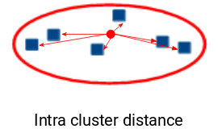](https://cdn.analyticsvidhya.com/wp-content/uploads/2019/08/Screenshot-from-2019-08-08-15-32-17.png)

Now, what do you think should be the value of inertia for a good cluster? Is a small inertial value good, or do we need a larger value? We want the points within the same cluster to be similar to each other, right? Hence, **the distance between them should be as low as possible**.

Dunn Index

We now know that inertia tries to minimize the intracluster distance. It is trying to make more compact clusters.

Let me put it this way – if the distance between the centroid of a cluster and the points in that cluster is small, it means that the points are closer to each other. So, inertia makes sure that the first property of clusters is satisfied. But it does not care about the second property – that different clusters should be as different from each other as possible.

This is where the Dunn index comes into action.

[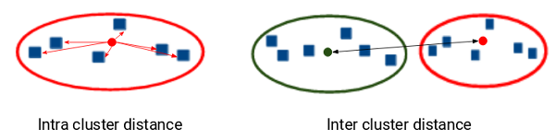](https://cdn.analyticsvidhya.com/wp-content/uploads/2019/08/Screenshot-from-2019-08-08-15-37-02.png)  
Along with the distance between the centroid and points,**the Dunn index also takes into account the distance between two clusters**. This distance between the centroids of two different clusters is known as**inter-cluster distance**. Let’s look at the formula of the Dunn index:

[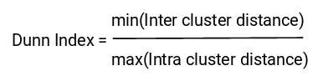](https://cdn.analyticsvidhya.com/wp-content/uploads/2019/08/Screenshot-from-2019-08-08-15-37-22.png)

We want to maximize the Dunn index. The more the value of the Dunn index, the better the clusters will be. Let’s understand the intuition behind the Dunn index:

[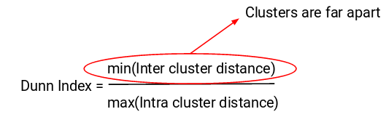](https://cdn.analyticsvidhya.com/wp-content/uploads/2019/08/Screenshot-from-2019-08-08-15-39-19.png)  
In order to maximize the value of the Dunn index, the numerator should be maximum. Here, we are taking the minimum of the inter-cluster distances. So, the distance between even the closest clusters should be more which will eventually make sure that the clusters are far away from each other.

[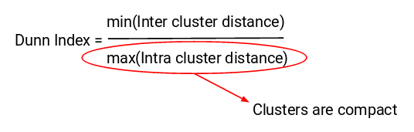](https://cdn.analyticsvidhya.com/wp-content/uploads/2019/08/Screenshot-from-2019-08-08-15-39-34.png)

Also, the denominator should be minimum to maximize the Dunn index. Here, we are taking the maximum of all intracluster distances. Again, the intuition is the same here. The maximum distance between the cluster centroids and the points should be minimum, eventually ensuring that the clusters are compact.

Silhouette Score

The silhouette score and plot are used to evaluate the quality of a clustering solution produced by the k-means algorithm. The silhouette score measures the similarity of each point to its own cluster compared to other clusters, and the silhouette plot visualizes these scores for each sample. A high silhouette score indicates that the clusters are well separated, and each sample is more similar to the samples in its own cluster than to samples in other clusters. A silhouette score close to 0 suggests overlapping clusters, and a negative score suggests poor clustering solutions.

What Is K-Means Clustering?

We have finally arrived at the meat of this article!

K-means clustering is a method for grouping n observations into K clusters. It uses vector quantization and aims to assign each observation to the cluster with the nearest mean or centroid, which serves as a prototype for the cluster. Originally developed for signal processing, K-means clustering is now widely used in machine learning to partition data points into K clusters based on their similarity. The goal is to minimize the sum of squared distances between the data points and their corresponding cluster centroids, resulting in clusters that are internally homogeneous and distinct from each other.

Recall the first property of clusters – it states that the points within a cluster should be similar to each other. So,**our aim here is to minimize the distance between the points within a cluster.**

K-means is a centroid-based algorithm or a distance-based algorithm, where we calculate the distances to assign a point to a cluster. In K-Means, each cluster is associated with a centroid.

Optimization plays a crucial role in the k-means clustering algorithm. The goal of the optimization process is to find the best set of centroids that minimizes the sum of squared distances between each data point and its closest centroid. This process is repeated multiple times until convergence, resulting in the optimal clustering solution.

How to Apply K-Means Clustering Algorithm?

Let’s now take an example to understand how K-Means actually works:

[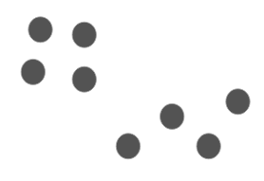](https://cdn.analyticsvidhya.com/wp-content/uploads/2019/08/Screenshot-from-2019-08-09-12-21-43.png)

We have these 8 points, and we want to apply k-means to create clusters for these points. Here’s how we can do it.

1. **Choose the number of clusters *k***

The first step in k-means is to pick the number of clusters, k.

1. **Select k random points from the data as centroids**

Next, we randomly select the centroid for each cluster. Let’s say we want to have 2 clusters, so k is equal to 2 here. We then randomly select the centroid:  
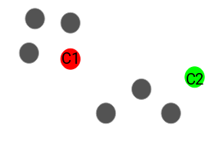  
Here, the red and green circles represent the centroid for these clusters.

1. **Assign all the points to the closest cluster centroid**

Once we have initialized the centroids, we assign each point to the closest cluster centroid: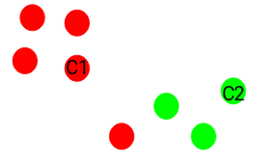  
Here you can see that the points closer to the red point are assigned to the red cluster, whereas the points closer to the green point are assigned to the green cluster.

1. **Recompute the centroids of newly formed clusters**

Now, once we have assigned all of the points to either cluster, the next step is to compute the centroids of newly formed clusters:  
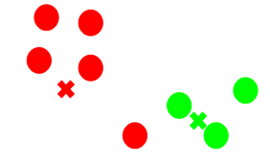  
Here, the red and green crosses are the new centroids.

1. **Repeat steps 3 and 4**

We then repeat steps 3 and 4:  
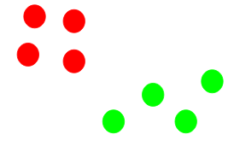  
*The step of computing the centroid and assigning all the points to the cluster based on their distance from the centroid is a single iteration*. But wait – when should we stop this process? It can’t run till eternity, right?

Stopping Criteria for K-Means Clustering

There are essentially three stopping criteria that can be adopted to stop the K-means algorithm:

1. Centroids of newly formed clusters do not change
2. Points remain in the same cluster
3. Maximum number of iterations is reached

We can stop the algorithm if the centroids of newly formed clusters are not changing. Even after multiple iterations, if we are getting the same centroids for all the clusters, we can say that the algorithm is not learning any new pattern, and it is a sign to stop the training.

Another clear sign that we should stop the training process is if the points remain in the same cluster even after training the algorithm for multiple iterations.

Finally, we can stop the training if the maximum number of iterations is reached. Suppose we have set the number of iterations as 100. The process will repeat for 100 iterations before stopping.

Implementing K-Means Clustering in Python From Scratch

Time to fire up our Jupyter notebooks (or whichever IDE you use) and get our hands dirty in Python!

We will be working on the loan prediction dataset that you can download [here](https://drive.google.com/file/d/1ZzEouo7lRJvajxK6jLM2K_p9xAwGw1tS/view?usp=sharing). I encourage you to read more about the dataset and the problem statement [here](https://datahack.analyticsvidhya.com/contest/practice-problem-loan-prediction-iii/?utm_source=blog&utm_medium=comprehensive-guide-k-means-clustering). This will help you visualize what we are working on (and why we are doing this). Two pretty important questions in any data science project.

First, import all the required libraries:

|  |  |
| --- | --- |
|  | #import libraries |
|  | import pandas as pd |
|  | import numpy as np |
|  | import random as rd |
|  | import matplotlib.pyplot as plt |

[view raw](https://gist.github.com/PulkitS01/97c9920b1c913ba5e7e101d0e9030b0e/raw/4691a5a909b75dc7d67d13dd10de008ac315f530/library.py)[library.py](https://gist.github.com/PulkitS01/97c9920b1c913ba5e7e101d0e9030b0e#file-library-py)hosted with  by [GitHub](https://github.com/)

Now, we will read the CSV file and look at the first five rows of the data:

|  |  |
| --- | --- |
|  | data = pd.read_csv('clustering.csv') |
|  | data.head() |

[view raw](https://gist.github.com/PulkitS01/97c9920b1c913ba5e7e101d0e9030b0e/raw/4691a5a909b75dc7d67d13dd10de008ac315f530/data.py)[data.py](https://gist.github.com/PulkitS01/97c9920b1c913ba5e7e101d0e9030b0e#file-data-py)hosted with  by [GitHub](https://github.com/)

[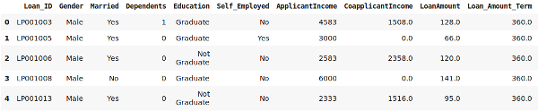](https://cdn.analyticsvidhya.com/wp-content/uploads/2019/08/Screenshot-from-2019-08-09-12-54-12.png)

For this article, we will be taking only two variables from the data – “LoanAmount” and “ApplicantIncome.” This will make it easy to visualize the steps as well. Let’s pick these two variables and visualize the data points:

**Python Code:**

[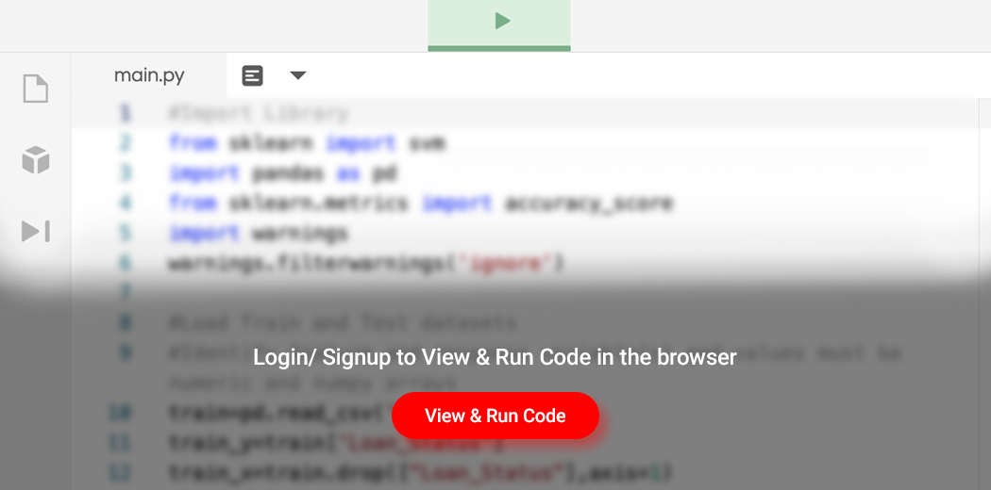](https://id.analyticsvidhya.com/auth/login/?next=https://www.analyticsvidhya.com/blog/2019/08/comprehensive-guide-k-means-clustering/?&utm_source=coding-window-blog&source=coding-window-blog)

[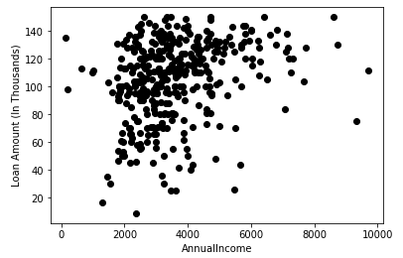](https://cdn.analyticsvidhya.com/wp-content/uploads/2019/08/Screenshot-from-2019-08-09-12-56-38.png)  
Steps 1 and 2 of K-Means were about choosing the number of clusters (k) and selecting random centroids for each cluster. We will pick 3 clusters and then select random observations from the data as the centroids:

|  |  |
| --- | --- |
|  | # Step 1 and 2 - Choose the number of clusters (k) and select random centroid for each cluster |
|  |  |
|  | #number of clusters |
|  | K=3 |
|  |  |
|  | # Select random observation as centroids |
|  | Centroids = (X.sample(n=K)) |
|  | plt.scatter(X["ApplicantIncome"],X["LoanAmount"],c='black') |
|  | plt.scatter(Centroids["ApplicantIncome"],Centroids["LoanAmount"],c='red') |
|  | plt.xlabel('AnnualIncome') |
|  | plt.ylabel('Loan Amount (In Thousands)') |
|  | plt.show() |

[view raw](https://gist.github.com/PulkitS01/97c9920b1c913ba5e7e101d0e9030b0e/raw/4691a5a909b75dc7d67d13dd10de008ac315f530/random_initialize.py)[random_initialize.py](https://gist.github.com/PulkitS01/97c9920b1c913ba5e7e101d0e9030b0e#file-random_initialize-py)hosted with  by [GitHub](https://github.com/)

[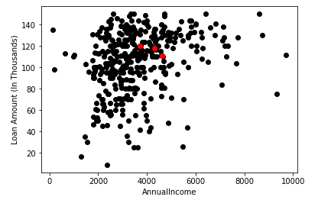](https://cdn.analyticsvidhya.com/wp-content/uploads/2019/08/Screenshot-from-2019-08-09-12-58-58.png)

Here, the red dots represent the 3 centroids for each cluster. Note that we have chosen these points randomly, and hence every time you run this code, you might get different centroids.

Next, we will define some conditions to implement the K-Means Clustering algorithm. Let’s first look at the code:

|  |  |
| --- | --- |
|  | # Step 3 - Assign all the points to the closest cluster centroid |
|  | # Step 4 - Recompute centroids of newly formed clusters |
|  | # Step 5 - Repeat step 3 and 4 |
|  |  |
|  | diff = 1 |
|  | j=0 |
|  |  |
|  | while(diff!=0): |
|  | XD=X |
|  | i=1 |
|  | for index1,row_c in Centroids.iterrows(): |
|  | ED=[] |
|  | for index2,row_d in XD.iterrows(): |
|  | d1=(row_c["ApplicantIncome"]-row_d["ApplicantIncome"])**2 |
|  | d2=(row_c["LoanAmount"]-row_d["LoanAmount"])**2 |
|  | d=np.sqrt(d1+d2) |
|  | ED.append(d) |
|  | X[i]=ED |
|  | i=i+1 |
|  |  |
|  | C=[] |
|  | for index,row in X.iterrows(): |
|  | min_dist=row[1] |
|  | pos=1 |
|  | for i in range(K): |
|  | if row[i+1] < min_dist: |
|  | min_dist = row[i+1] |
|  | pos=i+1 |
|  | C.append(pos) |
|  | X["Cluster"]=C |
|  | Centroids_new = X.groupby(["Cluster"]).mean()[["LoanAmount","ApplicantIncome"]] |
|  | if j == 0: |
|  | diff=1 |
|  | j=j+1 |
|  | else: |
|  | diff = (Centroids_new['LoanAmount'] - Centroids['LoanAmount']).sum() + (Centroids_new['ApplicantIncome'] - Centroids['ApplicantIncome']).sum() |
|  | print(diff.sum()) |
|  | Centroids = X.groupby(["Cluster"]).mean()[["LoanAmount","ApplicantIncome"]] |

[view raw](https://gist.github.com/PulkitS01/97c9920b1c913ba5e7e101d0e9030b0e/raw/4691a5a909b75dc7d67d13dd10de008ac315f530/kmeans_scratch.py)[kmeans_scratch.py](https://gist.github.com/PulkitS01/97c9920b1c913ba5e7e101d0e9030b0e#file-kmeans_scratch-py)hosted with  by [GitHub](https://github.com/)

[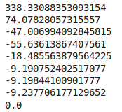](https://cdn.analyticsvidhya.com/wp-content/uploads/2019/08/Screenshot-from-2019-08-09-13-05-36.png)

These values might vary every time we run this. Here, we are stopping the training when the centroids are not changing after two iterations. This is the most common convergence criteria used for the K-Means clustering. We have initially defined the *diff* as 1, and inside the whole loop, we are calculating this *diff* as the difference between the centroids in the previous iteration and the current iteration.

When this difference is 0, we stop the training. Let’s now visualize the clusters we have got:

|  |  |
| --- | --- |
|  | color=['blue','green','cyan'] |
|  | for k in range(K): |
|  | data=X[X["Cluster"]==k+1] |
|  | plt.scatter(data["ApplicantIncome"],data["LoanAmount"],c=color[k]) |
|  | plt.scatter(Centroids["ApplicantIncome"],Centroids["LoanAmount"],c='red') |
|  | plt.xlabel('Income') |
|  | plt.ylabel('Loan Amount (In Thousands)') |
|  | plt.show() |

[view raw](https://gist.github.com/PulkitS01/97c9920b1c913ba5e7e101d0e9030b0e/raw/4691a5a909b75dc7d67d13dd10de008ac315f530/cluster_visualization.py)[cluster_visualization.py](https://gist.github.com/PulkitS01/97c9920b1c913ba5e7e101d0e9030b0e#file-cluster_visualization-py)hosted with  by [GitHub](https://github.com/)

[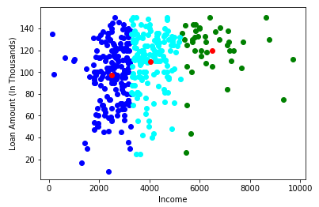](https://cdn.analyticsvidhya.com/wp-content/uploads/2019/08/Screenshot-from-2019-08-09-13-09-47.png)

Awesome! Here, we can clearly visualize three clusters. The red dots represent the centroid of each cluster. I hope you now have a clear understanding of how K-Means work.

However, there are certain situations where this algorithm might not perform as well. Let’s look at some challenges you can face while working with k-means.

Challenges With the K-Means Clustering Algorithm And

The k value in k-means clustering is a crucial parameter that determines the number of clusters to be formed in the dataset. Finding the optimal k value in the k-means clustering can be very challenging, especially for noisy data. The appropriate value of k depends on the data structure and the problem being solved. It is important to choose the right value of k, as a small value can result in under-clustered data, and a large value can cause over-clustering.

Challenges

**Also, one of the common challenges we face while working with K-Means is that the size of clusters is different**. Let’s say we have the following points:

[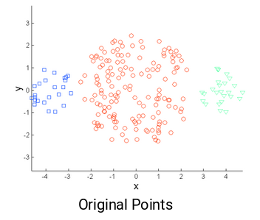](https://cdn.analyticsvidhya.com/wp-content/uploads/2019/08/Screenshot-from-2019-08-09-13-14-37.png)  
The leftmost and the rightmost clusters are of smaller size compared to the central cluster. Now, if we apply k-means clustering on these points, the results will be something like this:

[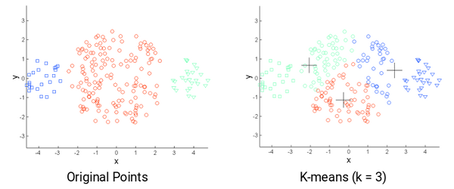](https://cdn.analyticsvidhya.com/wp-content/uploads/2019/08/Screenshot-from-2019-08-09-13-15-26.png)  
**Another challenge with k-means is when the densities of the original points are different.** Let’s say these are the original points:

[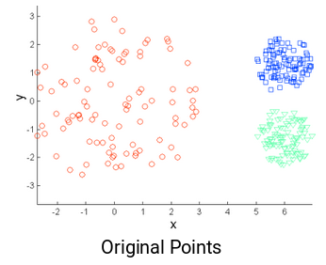](https://cdn.analyticsvidhya.com/wp-content/uploads/2019/08/Screenshot-from-2019-08-09-13-16-01.png)  
Here, the points in the red cluster are spread out, whereas the points in the remaining clusters are closely packed together. Now, if we apply k-means on these points, we will get clusters like this:

[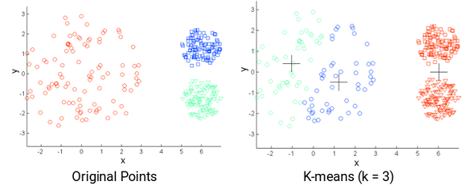](https://cdn.analyticsvidhya.com/wp-content/uploads/2019/08/Screenshot-from-2019-08-09-13-19-05.png)

We can see that the compact points have been assigned to a single cluster. Whereas the points that are spread loosely but were in the same cluster have been assigned to different clusters. Not ideal, so what can we do about this?

Solutions

**One of the solutions is to use a higher number of clusters.** So, in all the above scenarios, instead of using 3 clusters, we can have a bigger number. Perhaps setting k=10 might lead to more meaningful clusters.

Remember how we randomly initialize the centroids in k-means clustering? Well, this is also potentially problematic because we might get different clusters every time. So, to solve this problem of random initialization, there is an algorithm called **K-Means++** that can be used to choose the initial values, or the initial cluster centroids, for K-Means.

**Determining the optimal number of clusters for k-means clustering can be another challenge** as it heavily relies on subjective interpretations and the underlying structure of the data. One commonly used method to find the optimal number of clusters is the elbow method, which plots the sum of squared Euclidean distances between data points and their cluster center and chooses the number of clusters where the change in the sum of squared distances begins to level off.

**Outliers can have a significant impact on the results of k-means clustering, as the algorithm is sensitive to extreme values.** This makes it important to identify and handle outliers before applying k-means clustering to ensure that the results are meaningful and not skewed by the presence of outliers. There are various methods to identify and handle outliers, such as removing them, transforming them, or using a robust variant of k-means clustering that is less sensitive to the presence of outliers.

The algorithm can handle millions of data points and produce results in a matter of seconds or minutes, making it a popular choice for analyzing big data. **However, as the size of the data set increases, the computational cost of k-means clustering can also increase**. Hence, it is important to consider alternative algorithms when working with extremely large data sets.

K-Means++ to Choose Initial Cluster Centroids for K-Means Clustering

In some cases, if the initialization of clusters is not appropriate, K-Means can result in arbitrarily bad clusters. This is where K-Means++ helps. **It specifies a procedure to initialize the cluster centers before moving forward with the standard k-means clustering algorithm.**

Using the K-Means++ algorithm, we optimize the step where we randomly pick the cluster centroid. We are more likely to find a solution that is competitive with the optimal K-Means solution while using the K-Means++ initialization.

The steps to initialize the centroids using K-Means++ are:

1. The first cluster is chosen uniformly at random from the data points we want to cluster. This is similar to what we do in K-Means, but instead of randomly picking all the centroids, we just pick one centroid here
2. Next, we compute the distance (D(x)) of each data point (x) from the cluster center that has already been chosen
3. Then, choose the new cluster center from the data points with the probability of x being proportional to (D(x))2
4. We then repeat steps 2 and 3 until *k* clusters have been chosen

Let’s take an example to understand this more clearly. Let’s say we have the following points, and we want to make 3 clusters here:

[](https://cdn.analyticsvidhya.com/wp-content/uploads/2019/08/Screenshot-from-2019-08-09-12-21-431.png)  
Now, the first step is to randomly pick a data point as a cluster centroid:

[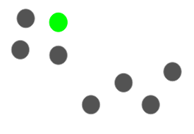](https://cdn.analyticsvidhya.com/wp-content/uploads/2019/08/Screenshot-from-2019-08-09-15-21-32.png)

Let’s say we pick the green point as the initial centroid. Now, we will calculate the distance (D(x)) of each data point with this centroid:

[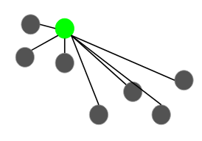](https://cdn.analyticsvidhya.com/wp-content/uploads/2019/08/Screenshot-from-2019-08-09-15-23-39.png)  
The next centroid will be the one whose squared distance (D(x)2) is the farthest from the current centroid:

[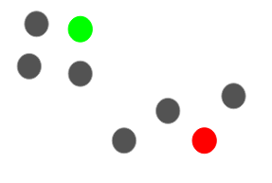](https://cdn.analyticsvidhya.com/wp-content/uploads/2019/08/Screenshot-from-2019-08-09-15-26-07.png)  
In this case, the red point will be selected as the next centroid. Now, to select the last centroid, we will take the distance of each point from its closest centroid, and the point having the largest squared distance will be selected as the next centroid:

[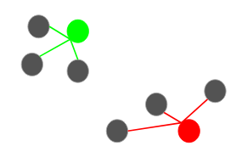](https://cdn.analyticsvidhya.com/wp-content/uploads/2019/08/Screenshot-from-2019-08-09-15-32-20.png)  
We will select the last centroid as:

[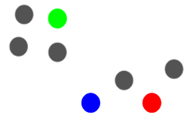](https://cdn.analyticsvidhya.com/wp-content/uploads/2019/08/Screenshot-from-2019-08-09-15-33-17.png)

We can continue with the K-Means algorithm after initializing the centroids. Using K-Means++ to initialize the centroids tends to improve the clusters. Although it is computationally costly relative to random initialization, subsequent K-Means often converge more rapidly.

I’m sure there’s one question that you’ve been wondering since the start of this article – how many clusters should we make? In other words, what should be the optimum number of clusters to have while performing K-Means?

How to Choose the Right Number of Clusters in K-Means Clustering?

One of the most common doubts everyone has while working with K-Means is selecting the right number of clusters.

So, let’s look at a technique that will help us choose the right value of clusters for the K-Means algorithm. Let’s take the customer segmentation example that we saw earlier. To recap, the bank wants to segment its customers based on their income and amount of debt:

[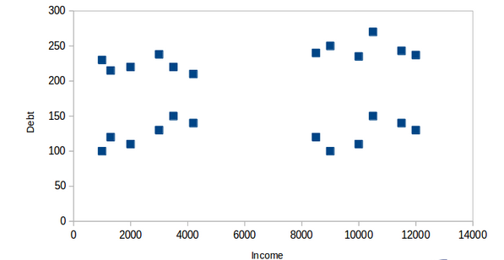](https://cdn.analyticsvidhya.com/wp-content/uploads/2019/08/Screenshot-from-2019-08-09-15-51-38.png)  
Here, we can have two clusters which will separate the customers as shown below:

[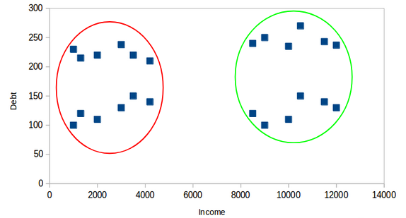](https://cdn.analyticsvidhya.com/wp-content/uploads/2019/08/Screenshot-from-2019-08-09-15-53-27.png)  
All the customers with low income are in one cluster, whereas the customers with high income are in the second cluster. We can also have 4 clusters:

[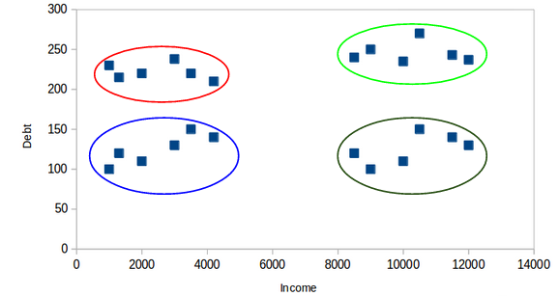](https://cdn.analyticsvidhya.com/wp-content/uploads/2019/08/Screenshot-from-2019-08-09-15-54-09.png)  
Here, one cluster might represent customers who have low income and low debt; another cluster is where customers have high income and high debt, and so on. There can be 8 clusters as well:

[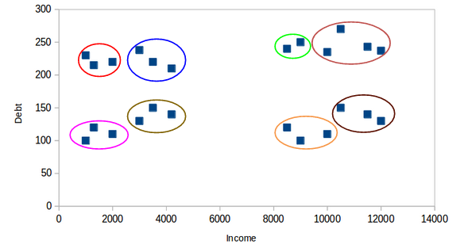](https://cdn.analyticsvidhya.com/wp-content/uploads/2019/08/Screenshot-from-2019-08-09-15-54-58.png)

Honestly, we can have any number of clusters. Can you guess what would be the maximum number of possible clusters? One thing we can do is assign each point to a separate cluster. Hence, in this case, the number of clusters will equal the number of points or observations. So,

***The maximum possible number of clusters will be equal to the number of observations in the dataset.***

But then, how can we decide the optimum number of clusters? **One thing we can do is plot a graph, also known as an elbow curve, where the x-axis will represent the number of clusters and the y-axis will be an evaluation metric.** Let’s say inertia for now.

You can choose any other evaluation metric like the Dunn index as well:

[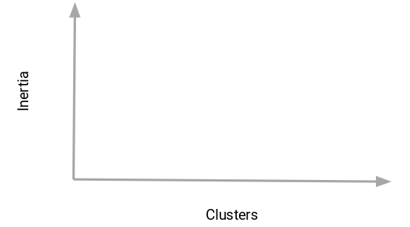](https://cdn.analyticsvidhya.com/wp-content/uploads/2019/08/Screenshot-from-2019-08-09-15-56-31.png)

Next, we will start with a small cluster value, say 2. Train the model using 2 clusters, calculate the inertia for that model, and finally plot it in the above graph. Let’s say we got an inertia value of around 1000:

[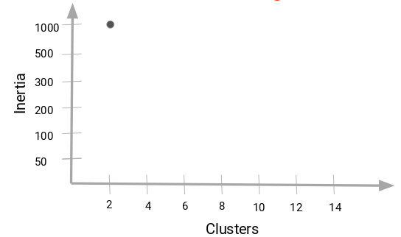](https://cdn.analyticsvidhya.com/wp-content/uploads/2019/08/Screenshot-from-2019-08-09-15-57-51.png)  
Now, we will increase the number of clusters, train the model again, and plot the inertia value. This is the plot we get:

[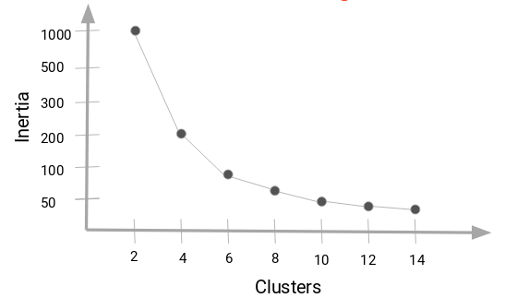](https://cdn.analyticsvidhya.com/wp-content/uploads/2019/08/Screenshot-from-2019-08-09-15-59-05.png)

When we changed the cluster value from 2 to 4, the inertia value reduced sharply. This decrease in the inertia value reduces and eventually becomes constant as we increase the number of clusters further.

[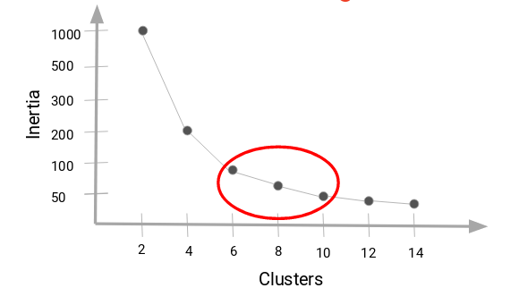](https://cdn.analyticsvidhya.com/wp-content/uploads/2019/08/Screenshot-from-2019-08-09-16-01-34.png)

Here, we can choose any number of clusters between 6 and 10. We can have 7, 8, or even 9 clusters. **You must also look at the computation cost while deciding the number of clusters.** If we increase the number of clusters, the computation cost will also increase. So, if you do not have high computational resources, my advice is to choose a lesser number of clusters.

Let’s now implement the K-Means Clustering algorithm in Python. We will also see how to use K-Means++ to initialize the centroids and will also plot this elbow curve to decide what should be the right number of clusters for our dataset.

Implementing K-Means Clustering in Python

We will be working on a wholesale customer segmentation problem. You can download the dataset using [this link](https://archive.ics.uci.edu/ml/machine-learning-databases/00292/Wholesale%20customers%20data.csv). The data is hosted on the UCI Machine Learning repository.

**The aim of this problem is to segment the clients of a wholesale distributor based on their annual spending on diverse product categories, like milk, grocery, region, etc.** So, let’s start coding!

We will first import the required libraries:

|  |  |
| --- | --- |
|  | # importing required libraries |
|  | import pandas as pd |
|  | import numpy as np |
|  | import matplotlib.pyplot as plt |
|  | %matplotlib inline |
|  | from sklearn.cluster import KMeans |

[view raw](https://gist.github.com/PulkitS01/97c9920b1c913ba5e7e101d0e9030b0e/raw/4691a5a909b75dc7d67d13dd10de008ac315f530/library_2.py)[library_2.py](https://gist.github.com/PulkitS01/97c9920b1c913ba5e7e101d0e9030b0e#file-library_2-py)hosted with  by [GitHub](https://github.com/)

Next, let’s read the data and look at the first five rows:

|  |  |
| --- | --- |
|  | # reading the data and looking at the first five rows of the data |
|  | data=pd.read_csv("Wholesale customers data.csv") |
|  | data.head() |

[view raw](https://gist.github.com/PulkitS01/97c9920b1c913ba5e7e101d0e9030b0e/raw/4691a5a909b75dc7d67d13dd10de008ac315f530/wholesale_data.py)[wholesale_data.py](https://gist.github.com/PulkitS01/97c9920b1c913ba5e7e101d0e9030b0e#file-wholesale_data-py)hosted with  by [GitHub](https://github.com/)

[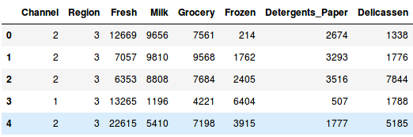](https://cdn.analyticsvidhya.com/wp-content/uploads/2019/08/Screenshot-from-2019-08-09-16-34-04.png)  
We have the spending details of customers on different products like Milk, Grocery, Frozen, Detergents, etc. Now, we have to segment the customers based on the provided details. Before doing that, let’s pull out some statistics related to the data:

|  |  |
| --- | --- |
|  | # statistics of the data |
|  | data.describe() |

[view raw](https://gist.github.com/PulkitS01/97c9920b1c913ba5e7e101d0e9030b0e/raw/4691a5a909b75dc7d67d13dd10de008ac315f530/data_statistics.py)[data_statistics.py](https://gist.github.com/PulkitS01/97c9920b1c913ba5e7e101d0e9030b0e#file-data_statistics-py)hosted with  by [GitHub](https://github.com/)

[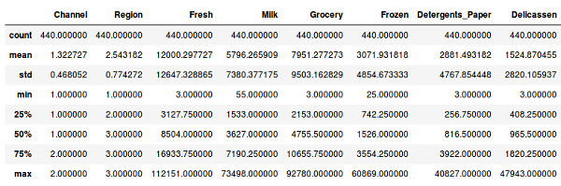](https://cdn.analyticsvidhya.com/wp-content/uploads/2019/08/Screenshot-from-2019-08-09-16-36-28.png)

Here, we see that there is a lot of variation in the magnitude of the data. Variables like Channel and Region have low magnitude, whereas variables like Fresh, Milk, Grocery, etc., have a higher magnitude.

Since K-Means is a distance-based algorithm, this difference in magnitude can create a problem. So let’s first bring all the variables to the same magnitude:

|  |  |
| --- | --- |
|  | # standardizing the data |
|  | from sklearn.preprocessing import StandardScaler |
|  | scaler = StandardScaler() |
|  | data_scaled = scaler.fit_transform(data) |
|  |  |
|  | # statistics of scaled data |
|  | pd.DataFrame(data_scaled).describe() |

[view raw](https://gist.github.com/PulkitS01/97c9920b1c913ba5e7e101d0e9030b0e/raw/4691a5a909b75dc7d67d13dd10de008ac315f530/standardize.py)[standardize.py](https://gist.github.com/PulkitS01/97c9920b1c913ba5e7e101d0e9030b0e#file-standardize-py)hosted with  by [GitHub](https://github.com/)

[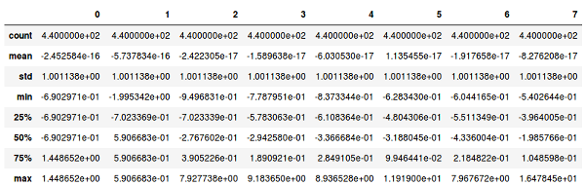](https://cdn.analyticsvidhya.com/wp-content/uploads/2019/08/Screenshot-from-2019-08-09-16-39-31.png)  
The magnitude looks similar now. Next, let’s create a *kmeans* function and fit it on the data:

|  |  |
| --- | --- |
|  | # defining the kmeans function with initialization as k-means++ |
|  | kmeans = KMeans(n_clusters=2, init='k-means++') |
|  |  |
|  | # fitting the k means algorithm on scaled data |
|  | kmeans.fit(data_scaled) |

[view raw](https://gist.github.com/PulkitS01/97c9920b1c913ba5e7e101d0e9030b0e/raw/4691a5a909b75dc7d67d13dd10de008ac315f530/kmeans.py)[kmeans.py](https://gist.github.com/PulkitS01/97c9920b1c913ba5e7e101d0e9030b0e#file-kmeans-py)hosted with  by [GitHub](https://github.com/)

We have initialized two clusters and pay attention – the initialization is not random here. We have used the k-means++ initialization which generally produces better results as we have discussed in the previous section as well.

Let’s evaluate how well the formed clusters are. To do that, we will calculate the inertia of the clusters:

|  |  |
| --- | --- |
|  | # inertia on the fitted data |
|  | kmeans.inertia_ |

[view raw](https://gist.github.com/PulkitS01/97c9920b1c913ba5e7e101d0e9030b0e/raw/4691a5a909b75dc7d67d13dd10de008ac315f530/inertia.py)[inertia.py](https://gist.github.com/PulkitS01/97c9920b1c913ba5e7e101d0e9030b0e#file-inertia-py)hosted with  by [GitHub](https://github.com/)

**Output:** 2599.38555935614

We got an inertia value of almost 2600. Now, let’s see how we can use the elbow method to determine the optimum number of clusters in Python.

We will first fit multiple k-means models, and in each successive model, we will increase the number of clusters. We will store the inertia value of each model and then plot it to visualize the result:

|  |  |
| --- | --- |
|  | # fitting multiple k-means algorithms and storing the values in an empty list |
|  | SSE = [] |
|  | for cluster in range(1,20): |
|  | kmeans = KMeans(n_jobs = -1, n_clusters = cluster, init='k-means++') |
|  | kmeans.fit(data_scaled) |
|  | SSE.append(kmeans.inertia_) |
|  |  |
|  | # converting the results into a dataframe and plotting them |
|  | frame = pd.DataFrame({'Cluster':range(1,20), 'SSE':SSE}) |
|  | plt.figure(figsize=(12,6)) |
|  | plt.plot(frame['Cluster'], frame['SSE'], marker='o') |
|  | plt.xlabel('Number of clusters') |
|  | plt.ylabel('Inertia') |

[view raw](https://gist.github.com/PulkitS01/97c9920b1c913ba5e7e101d0e9030b0e/raw/4691a5a909b75dc7d67d13dd10de008ac315f530/elbow_curve.py)[elbow_curve.py](https://gist.github.com/PulkitS01/97c9920b1c913ba5e7e101d0e9030b0e#file-elbow_curve-py)hosted with  by [GitHub](https://github.com/)

[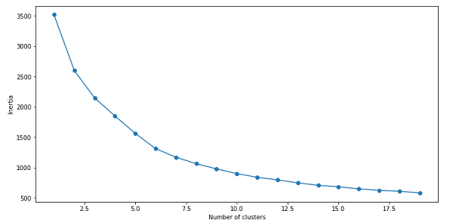](https://cdn.analyticsvidhya.com/wp-content/uploads/2019/08/Screenshot-from-2019-08-09-16-46-52.png)  
Can you tell the optimum cluster value from this plot? Looking at the above elbow curve, **we can choose any number of clusters between 5 to 8**. Let’s set the number of clusters as 6 and fit the model:

|  |  |
| --- | --- |
|  | # k means using 5 clusters and k-means++ initialization |
|  | kmeans = KMeans(n_jobs = -1, n_clusters = 5, init='k-means++') |
|  | kmeans.fit(data_scaled) |
|  | pred = kmeans.predict(data_scaled) |

[view raw](https://gist.github.com/PulkitS01/97c9920b1c913ba5e7e101d0e9030b0e/raw/4691a5a909b75dc7d67d13dd10de008ac315f530/final_kmeans.py)[final_kmeans.py](https://gist.github.com/PulkitS01/97c9920b1c913ba5e7e101d0e9030b0e#file-final_kmeans-py)hosted with  by [GitHub](https://github.com/)

Finally, let’s look at the value count of points in each of the above-formed clusters:

|  |  |
| --- | --- |
|  | frame = pd.DataFrame(data_scaled) |
|  | frame['cluster'] = pred |
|  | frame['cluster'].value_counts() |

[view raw](https://gist.github.com/PulkitS01/97c9920b1c913ba5e7e101d0e9030b0e/raw/4691a5a909b75dc7d67d13dd10de008ac315f530/cluster_count.py)[cluster_count.py](https://gist.github.com/PulkitS01/97c9920b1c913ba5e7e101d0e9030b0e#file-cluster_count-py)hosted with  by [GitHub](https://github.com/)

[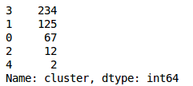](https://cdn.analyticsvidhya.com/wp-content/uploads/2019/08/Screenshot-from-2019-08-09-16-55-02.png)  
So, there are 234 data points belonging to cluster 4 (index 3), 125 points in cluster 2 (index 1), and so on. This is how we can implement K-Means Clustering in Python.

Conclusion

In this article, we discussed one of the most famous clustering algorithms – K-Means. We implemented it from scratch and looked at its step-by-step implementation. We looked at the challenges we might face while working with K-Means and also saw how K-Means++ can be helpful when initializing the cluster centroids.

Finally, we implemented k-means and looked at the elbow method, which helps to find the optimum number of clusters in the K-Means algorithm.

If you have any doubts or feedback, feel free to share them in the comments section below. And make sure you check out the comprehensive ‘[**Applied Machine Learning**](https://courses.analyticsvidhya.com/courses/applied-machine-learning-beginner-to-professional/?utm_source=blog&utm_medium=comprehensive-guide-k-means-clustering)‘ course that takes you from the basics of machine learning to advanced algorithms (including an entire module on deploying your machine learning models!).

**Key Takeaways**

* K-Means Clustering is a simple yet powerful algorithm in data science.
* The algorithm works to group together or form clusters of data points from an unlabeled dataset.
* It is used in a plethora of real-world situations across various domains, such as banking and image segmentation, to document clustering and business decision-making.

Frequently Asked Questions

**Q1. What is K-means clustering?**

A. K-Means Clustering is an Unsupervised Learning algorithm used to group data points in an unlabeled dataset into different clusters based on closest proximity.

**Q2. What is the K Means algorithm mainly used for?**

A. The K-means clustering algorithm is mainly used in cases where you do not have a specific outcome variable that you are trying to predict but instead have a set of observations or value you wish to cluster based on similar features. It is used by businesses to make better decisions, by apps and engines that give recommendations, and by cyber security firms, amongst many others.

**Q3. What are the benefits of K-means clustering?**

A. The biggest benefit of K-means clustering is that it is faster than hierarchical clustering. It is easy to implement, can work with a large number of variables, and can quickly change clusters when the centroids are recomputed.